Security in Computing Practical 8
Layer 2 VLAN Security Configuration
Practical 8: Layer 2 VLAN Security

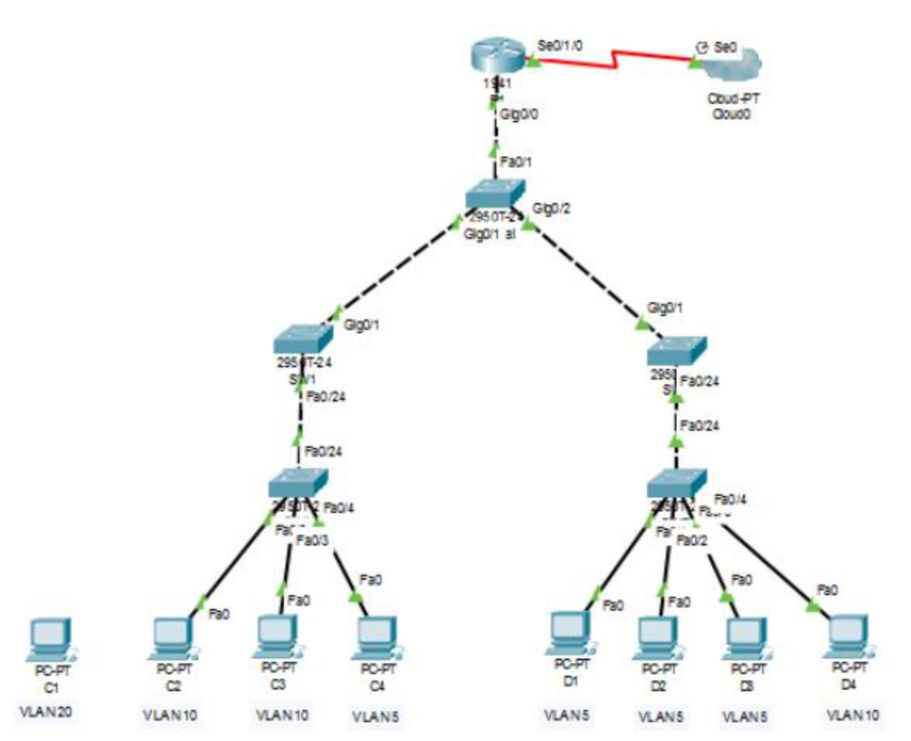
Topology:

Basic Configuration (Router & Switches)
enable
conf t
enable secret enpa55
line console 0
password conpa55
login
exit
ip domain-name ccnasecurity.com
username admin secret adminpa55
line vty 0 4
login local
transport input ssh
exit
crypto key generate rsa
1024
end
wr

VLAN Configuration
vlan 5
vlan 10
vlan 15
vlan 20

Access Port Configuration
! SWA
interface fa0/2
switchport mode access
switchport access vlan 10
interface fa0/3
switchport mode access
switchport access vlan 10
interface fa0/4
switchport mode access
switchport access vlan 5
! SWB
interface fa0/1
switchport mode access
switchport access vlan 5
interface fa0/2
switchport mode access
switchport access vlan 5
interface fa0/3
switchport mode access
switchport access vlan 5
interface fa0/4
switchport mode access
switchport access vlan 10

Trunk Configuration
interface fa0/24
switchport mode trunk
switchport trunk native vlan 15
interface fa0/23
switchport mode trunk
switchport trunk native vlan 15
switchport nonegotiate

Router R1 Subinterfaces (Inter-VLAN Routing)
interface g0/0.1
encapsulation dot1q 5
ip address 192.168.5.100 255.255.255.0
interface g0/0.2
encapsulation dot1q 10
ip address 192.168.10.100 255.255.255.0
interface g0/0.15
encapsulation dot1q 15
ip address 192.168.15.100 255.255.255.0
interface g0/0.3
encapsulation dot1q 20
ip address 192.168.20.100 255.255.255.0

Management VLAN Configuration
interface vlan 20
ip address 192.168.20.X 255.255.255.0
! Assign PC to VLAN 20
interface fa0/1
switchport mode access
switchport access vlan 20

ACL Security Configuration
access-list 101 deny ip any 192.168.20.0 0.0.0.255
access-list 101 permit ip any any
access-list 102 permit ip host 192.168.20.50 any
interface g0/0.1
ip access-group 101 in
interface g0/0.2
ip access-group 101 in
line vty 0 4
access-class 102 in

Verification Steps
1. show vlan brief
2. show interfaces trunk
3. show ip interface brief
4. show access-lists
5. Test:
- VLAN communication works
- Management VLAN accessible only to admin PC
- Other PCs blocked
6. Ping tests:
C2 ↔ C3 (Success)
C2 ↔ D1 (Success)
D1 → Management VLAN (Fail)
Practical 8: VLAN Security
- On SWA and SWB:
  - show vlan brief: To ensure ports are assigned to the correct VLANs (5, 10, 15, 20).
  - show interfaces trunk: To verify the native VLAN is set to 15 and nonegotiate is active.
- On R1:
  - show ip interface brief: To verify subinterfaces (g0/0.1, g0/0.2, etc.) are up.
  - show access-lists: To check if ACL 101 is blocking traffic to the Management VLAN (20).

Practical 8: Layer 2 VLAN Security
On Router R1
- Sub-interfaces: Run show ip interface brief to check gig0/0.5, gig0/0.10, gig0/0.15, and gig0/0.20.
On Switches
- Trunk Status: Run show interfaces trunk on any switch to ensure Native VLAN is 15.
On Management PC (C1)
- Management Connectivity: Ping all switch IPs (192.168.20.1 to 192.168.20.5).
- Access Router: Run ping 192.168.20.100 (successful)

Viva Questions
1. What is VLAN?
Logical segmentation of network.
2. What is trunk?
Carries multiple VLAN traffic.
3. What is native VLAN?
Default VLAN for untagged traffic.
4. What is inter-VLAN routing?
Routing between VLANs using router.
5. Why VLAN security?
To isolate and protect network segments.

